

**Creating a game wandering in the woods using python language**

**Software Engineering (Sections SU22-CPSC-60500-001 & 002)**

Instructor’s name: Fadi Wedyan

Team members

Sandeep Perikala:

Naveen Madupoju

Arshiya Nooreen

Praneeth Somisetty

Khaja Ahmed Hussain Syed

**Table of Contents**

Abstract 3

Introduction: 3

Vision: 4

Scope: 4

Roadmap…………………………………………………………………………………………..4

Agile Software Development 4

Figure 1: Agile Process 5

Principles of Agile development 5

Agile development in our application 5

Project Requirements 6

Scenarios 6

Personas 6

Features of Store: 6

1. Simplicity: 6

2. Speed: 6

3. Flexibility: 7

4. Security: 7

5. Push Notifications: 7

6. User Feedback: 7

Use Stories for Buy and Sell Store: 7

Use Story 1: 7

Use Story 2: 8

Use Story 3: 8

Use Story 4: 8

Mobile Development Stack: 9

Infrastructure For Mobile Application: 9

Hardware: 9

Development: 10

MySQL: 10

Data Model for Application: 10

Application Architecture: 10

Data Flow Diagram: 10

UML Class Diagram: 11

Use Cases: 11

User Use Cases: 12

Create Account: 12

Brief Description: 12

Selling Car 12

Brief Description: 12

Buying Car 12

Brief Description: 12

Admin 12

Brief Description: 12

Security and Privacy Considerations: 13

Testing Strategies: 13

Functional Testing: 13

Unit Testing: 13

Integration Testing: 13

System Testing: 13

Acceptance Testing: 13

Non-Functional Testing: 14

Performance Testing: 14

Security Testing: 14

Usability Testing: 14

Compatibility Testing: 14

Branching and Deployment Strategy: 15

Summary of Project: 15

Feedback on the Project Experience: 15

Team Members and Contribution: 15

References 15

**Abstract**

This project is to build a game title "Wandering in the woods". It's a magical game where people roam around and different boxes in the grid are searched for mysterious things. The game ends when two players get same to each other.

# Introduction:

This game is designed for students of different grades with different comprehensions and games. For K-2nd grade, it's easier to just see the grid, and from the corner his two players start moving diagonally, both players collide, and the game ends with the Happy Him message.

3rd to He is a 4th grade student, 3 to He can be played by 4 players. Next level lesson phase. Once placed on the grid, stats are displayed in the right corner of every player.

From 6th grade to her 8th grade students will have a more advanced level change where students can change the grid.

# Vision:

The vision of this project is to teach students how to create games with interactive interfaces and experience the graphical screen in real life. Create splash screen, game on screen, game on screen like this game.

# Scope:

This game is especially for k-grades, 3-4 grades and 6-8 grades students. To give them a happy playing and mysterious game which make them curious about the next level.

1. **Roadmap:**

Following points clearly depicts the roadmap for building an online store to sell and purchase cars.

* Concept, planning and research.
* Team building, project development, website development and design.
* MVP development for web services platforms and website launch.
* Web services platform launch MVP development for online store including alpha testing.
* Web services platform (beta testing) mobile app launch, sponsorship and partnership.
* Mobile app and web services live and crypto exchange platform development.
* Online store launch with all testing.

# Agile Software Development

It is a form of Software Development that has an approach in which the project management team by solutions improvements and requirements discovery. In this there is delivery on time, team management, team collaboration, continuous planning, and also continuous learning. In this the work is divided in mint iteration and teams.

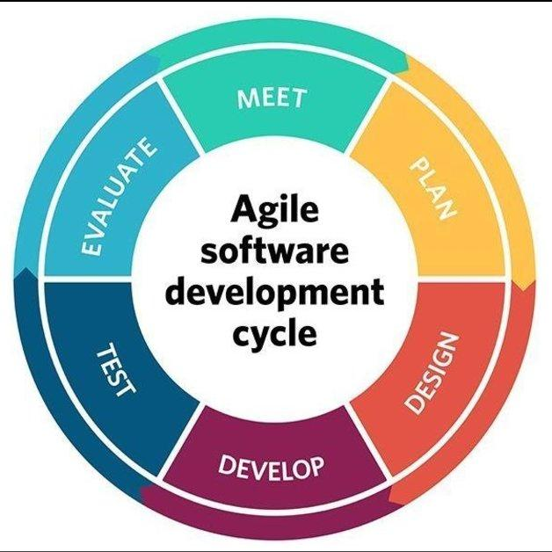

*Figure 1: Agile Process*

## 5.1 Principles of Agile development

As we know that customer satisfaction is very important and top-focused. To achieve the highest level of satisfaction we have to do face-to-face meetings. Satisfying customer service and delivery on time. Continuous attention and making your project efficient through meetings. Agile processes promote sustainable development. The sponsors, developers, and users should be able to maintain a constant pace indefinitely. The most efficient and effective method of conveying information to and within a development team is face-to-face conversation.

## 5.2 Agile development in our application

The agile development in our store is:

1. **Define the project:**

At the start before development, a product backlog is created. And in each sprint this backlog is refined by sprint team.

Here is an example of product backlog.

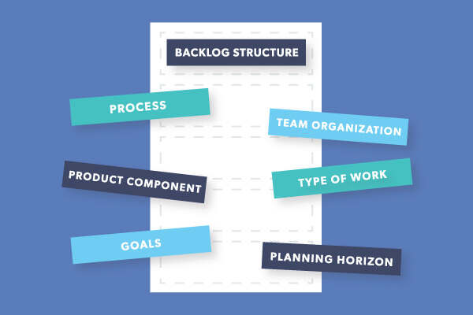

1. **Meeting hours:**

In agile scrum methodology a meeting document is prepared along with each sprint. The meeting document describes the meeting of scrum team with clients to discuss their requirements and new features to be added. It contains the time hours and venue of the meeting. In each sprint, sprint team must make meeting hours to understand the work which is to be completed during the sprint.

1. **Agile retrospective:**

In agile retrospective, a meeting is held at the end of the iteration in agile software development. Every team member is to answer the following questions:

What worked well for us?

What did not work well for us?

What actions can we take to improve our process going forward?

1. **Project Designing :**

* Design an environment for signup.
* Design an environment of login.
* Design a dashboard for customers.
* Design a dashboard for buying and selling.
* After designing send it to the testing team.
* If there are any defects they can fix them.

# Project Requirements

For this project the application is compulsory as also a website. Because when a user or customer wants to sell or buy his/her car, he/she has a platform to do this.

## 6.1 Scenarios

The scenarios of the use of this store include;

1. User will download the game to play.

## 6.2 Personas

The personas that will use the store include;

1. New user (Who has to create his/her account and register himself/herself.)

# Features of Store:

1. **Simplicity:**

Store will provide simplicity. If your software is difficult to use then users will lose interest as many individuals have short attention spans.

1. **Speed:**

As we know, ‘Everyone hates waiting’. So, your store application is too efficient and fast to engage customers

1. **Flexibility:**

Everyone wants flexibility. Your store application is too flexible that it runs on different operating systems like IoS, Android, or Windows.

1. **Security:**

As we know, security is important for any website or application or also in real life. Hackers are always active to cheat or fraud. Because of this your store application is too secured.

1. **Push Notifications:**

As we know that pop-up notification plays a very important role in this. This is very good for keeping customers up-to-date.

1. **User Feedback:**

User Feedback plays a very important role in the improvement of your product. By using this you can know the defects of your product.

# Use Stories for Buy and Sell Store:

**Use Story 1:**

|  |
| --- |
| As a **New User**, the Customer has to create his/her account and register himself/herself. |
| **Acceptance Criteria**   * New Users have to install an application of this store on his/her devices. |

# Mobile Development Stack:

This term refers to the tools, frameworks, programming languages, and other technologies that is used to create this. This store divided into:

* **User:** The person who is accessing this.
* **Front-end:** The interface that is created to show the objects, and the user can interact the technologies are used.
* **Back-end:** To use this we need back-to-back connection with server. That’s why Back-end is necessary.
* **Database:** This is used to store user data or credentials.

The Mobile Development Stack is given below:

# Infrastructure for Mobile Application:

**Hardware:**

This can be run on both Mobile and Computer. That’s why you can run it.

**Operating System:** This has many versions like Android, IOS, Windows and Linux operating systems. You have to install on your operating system that you are using.

# Security and Privacy Considerations:

As we know that, in everything security and privacy is very important. For making reliable software, we face the security issues. A strong end-to-end encryption is used to sore user credentials.

# Testing Strategies:

The following testing strategies are used:

* Functional Strategy
* Non-Functional Strategy

## Functional Testing:

In this form of testing, we test the application by following testing methods:

* Unit Testing
* Integration Testing
* System Testing
* Acceptance Testing

### Unit Testing:

In this testing, each components of the application are tested during the development process. Like buttons are working properly, input fields are taking inputs or not, and components are placed well.

### Integration Testing:

After unit testing, integration testing is tested. In this modules are made. In this testing, each module is tested either units are integrated or not. Like inputs fields and button are used in making forms.

### System Testing:

In this testing, whole system is tested. A team of testers test each components and modules.

### Acceptance Testing:

In this testing, the customers test it either it is working according to his/her requirements or not. The final system is tested wither it is completed or not.

## Non-Functional Testing:

In this testing, the following methods are used:

* Performance Testing
* Security Testing
* Usability Testing
* Compatibility Testing

### Performance Testing:

By performance testing we know the performance of the application.

* **Load Testing:** Multiple simulation are performed to check the performance of the application in this testing.
* **Stress Testing:** In this we can check the load that how much users does this application stored.
* **Spike Testing:** It is the form like load testing to check the burst of concurrent users. This is beneficial to check the sudden load.

### Security Testing:

In this testing, we check that how is our application secured as the security threats are increasing day by day. The encrypted data is used to secure this.

### Usability Testing:

In this testing, to check the use of designed system that is working properly. This is good for teams to check the bugs or defects.

Compatibility Testing:

In this form of testing, we know that compatibility of application by running it on different operating systems.

# Branching and Deployment Strategy:

* **Branching Strategy:** In this application we use this strategy to maintain our application up-to-date. It will be the first version after completing the testing. New branch is created if the changes are required in older version.
* **Deployment Strategy:** In this strategy we will test the new on limited servers and give some